Karnataka Valuation & E-Registration (KAVERI - 2.0)
Government of Karnataka

Functional Requirement Specifications

For KAVERI 2.0
Department of Stamps & Registration
Government of Karnataka

BDA Parking Registration

Prepared by
Centre for Smart Governance (CSG)
3rd Floor, TTMC Yeshwanthapura, BMTC Bus station
Bangalore – 560022

Contents
1 BDA Parking Registration 3
1.1 Introduction 3
1.2 Document scope 3
1.3 Overview of the function 3
1.4 Description of the functional requirement 4
1.4.1 As-Is: Existing process 4
1.4.2 To-Be: BDA parking registration 5
1.5 Assumptions 6
1.6 Validations 6
1.7 Integration with other systems/modules 6
1.7.1 External integration 6
1.7.2 Internal integration with other modules 6
1.8 Annexures 6
1.8.1 Annexure – 1 – List of modules of Kaveri 2.0 6
1.8.2 Annexure – 1 – Clarificatory questionnaire 8

BDA Parking Registration

Introduction
The Department of Stamps and Registration (henceforth referred to as “department”) is the custodian of registered public records such as Registration of Marriages and Firms, Documents pertaining to transactions namely sale, transfer or gift of immovable properties, Mortgage, Power of Attorneys, wills and many more. Maintenance and preservation of these critical public records is the prime responsibility of the department. The records or the information associated with registered records are to be made available to the public when requested through defined procedures. The department is also responsible for collecting stamp duty on behalf of the Government for specified transactions. The services are provided through 258 Sub-Registrar Offices (SROs), under the supervision of 35 District Registrar Offices, spread across the state.
The department has computerized the delivery of these services through the development of Kaveri software. KAVERI Online service is a web-based application of the department that provides an interface to the citizens required for documents, marriage, and firm registration. It enables citizens to know the details of stamp duty, property guidelines value, data entry for document registration and marriage registration, etc. The list of modules of Kaveri 2.0 is available in Annexure 1.

Document scope
This document is the Functional Requirement Specification (FRS), outlining the functional features of BDA parking registration within Kaveri 2.0. Currently, Kaveri 2.0 enables citizens to transact the BDA properties, including car parking. However, transactions involving only car parking on properties owned by BDA are not permitted. Implementing this feature facilitates citizens' transactions of only car parking properties by Sale.
Prepared by the Centre for Smart Governance (CSG) and formally approved by the department, this document is intended for the departmental approving authority and the development team.

Overview of the function
BDA parking registration

Figure 1: BDA parking registration function in Document registration
The BDA parking registration feature requires minor modifications during the application submission and SR scrutiny phases. There will be no market valuation involved as there is no transaction on property in both application submission and SR scrutiny phases. The detailed flow will be discussed further.

Description of the functional requirement

As-Is: Existing process

Interaction diagram of Application Submission
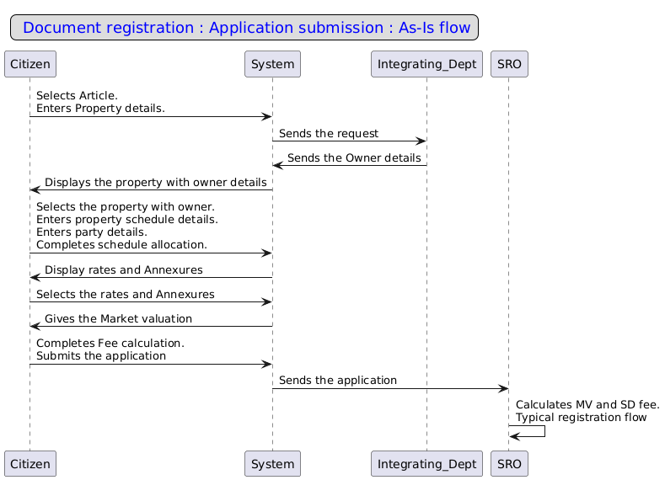
As-Is: Application Submission
- The citizen logs into Kaveri 2.0 and selects the Document Registration module.
- The citizen enters document details, including the nature of the document, article, and sub-article.
- The citizen selects the property type and enters the necessary details.
- The system retrieves the property owner's details from the integrating department.
- The citizen selects the property and inputs relevant data, including property and party details.
- After entering all required information, the citizen calculates the market valuation and stamp duty fee.
- The citizen uploads the executed deed copy along with relevant annexures.
- After uploading all required documents, the citizen selects the SRO and submits the application.
- The system forwards the application to the jurisdictional SRO dashboard for further processing.

To-Be: BDA parking registration

Interaction Diagram of Application Submission
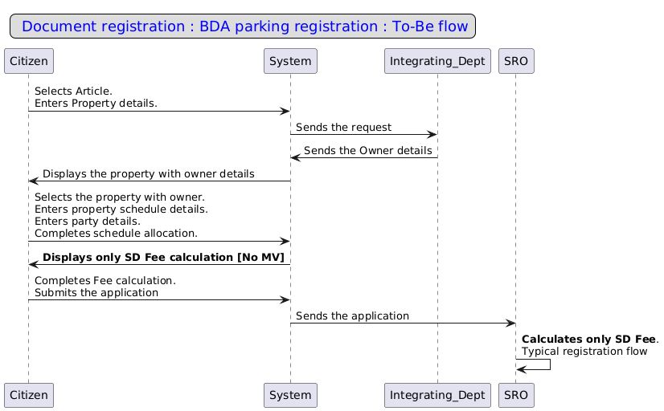

Article Selection | Property Search | Property Schedule | Executant details | Party Allocation | Market Valuation | Fee Calculation | SRO  selection and submission

To-Be: BDA parking registration: Application Submission
- Property search— Upon entering the property details, the system retrieves a list of associated properties and owner information. The user selects the property to which the parking transaction is made.
- Market valuation and Fee calculation – The system gives only fee calculation but no market valuation since there is only a transaction involving the parking area, not on the property.
- The user continues with the typical registration process.

Wireframes
Please find the wireframes in the attached pdf
Attachment

Assumptions
- The system allows the user to add multiple schedules for transacted parking area.
- Citizen can purchase these cars parking spaces without owning a flat.
- After transaction, XML be pushed as per the existing process.

Validations
N/A

Integration with other systems/modules

External integration
N/A

Internal integration with other modules
N/A

Annexures

Annexure – 1 – List of modules of Kaveri 2.0
Sl No | Module No | Main Module | Sub-Module
1 | 1.1 | Registration | Registration
2 | 1.2 | Registration | Appointment
3 | 1.3 | Registration | Integration module
4 | 1.4 | Registration | Stamp duty and Registration fee calculation
5 | 1.5 | Registration | Guideline value calculation
6 | 1.6 | Registration | Rule 17 (2) filing
7 | 1.7 | Registration | Rule 17 (3) filing
8 | 1.8 | Registration | Old pending release module
9 | 1.9 | Registration | Re-Registration module
10 | 1.1 | Registration | Will after Death
11 | 1.11 | Registration | Filing documents (FRUITS)
12 | 1.12 | Registration | Scanning
13 | 1.13 | Registration | Memo transmission and filing
14 | 1.14 | Registration | 68(2) correction
15 | 1.15 | Registration | Cross-reference Rule 123
16 | 1.16 | Registration | Integration exemption
17 | 1.17 | Registration | Court entry
18 | 1.18 | Registration | Liability
19 | 1.19 | Registration | Status tracking
20 | 1.2 | Registration | Investigation and Search
21 | 1.21 | Registration | Valuation Module (CVC)
22 | 2 | EC
23 | 3 | CC
24 | 4 | Verify Document
25 | 5 | Power of attorney Authentication Module
26 | 6 | Refund Module
27 | 7.1 | Marriage | Hindu Marriage
28 | 7.2 | Marriage | Special Marriage
29 | 7.3 | Marriage | Special Marriage in Other forms
30 | 8 | Legacy record digitisation
31 | 9 | Audit
32 | 10 | Accounts
33 | 11.1 | MIS | Statutory (44)
34 | 11.2 | MIS | Statistical (54)
35 | 11.3 | MIS | Integration (15)
36 | 11.4 | MIS | Computer related (4)
37 | 11.5 | MIS | Reconciliation (5)
38 | 11.6 | MIS | HR (5)
39 | 12.1 | DRO | Firm Registration
40 | 12.2 | DRO | Undervaluation
41 | 12.3 | DRO | Deposit of will
42 | 12.4 | DRO | Adjudication of documents
43 | 13 | IGRO | Appeal
44 | 14 | Master Data Management
45 | 15 | User Management
46 | 16 | Mobile application
47 | 17 | Training Module | Master Trainer, Training Plan

Annexure – 1 – Clarificatory questionnaire

- Is this process applicable to all existing articles?
- Is the new nature of the document, article and sub-article to be created?
- Are exemption and denotation fees applicable?
- What details are to be considered for checkbandi?
- Should we allow the transactions without the saleable area of the flat?

